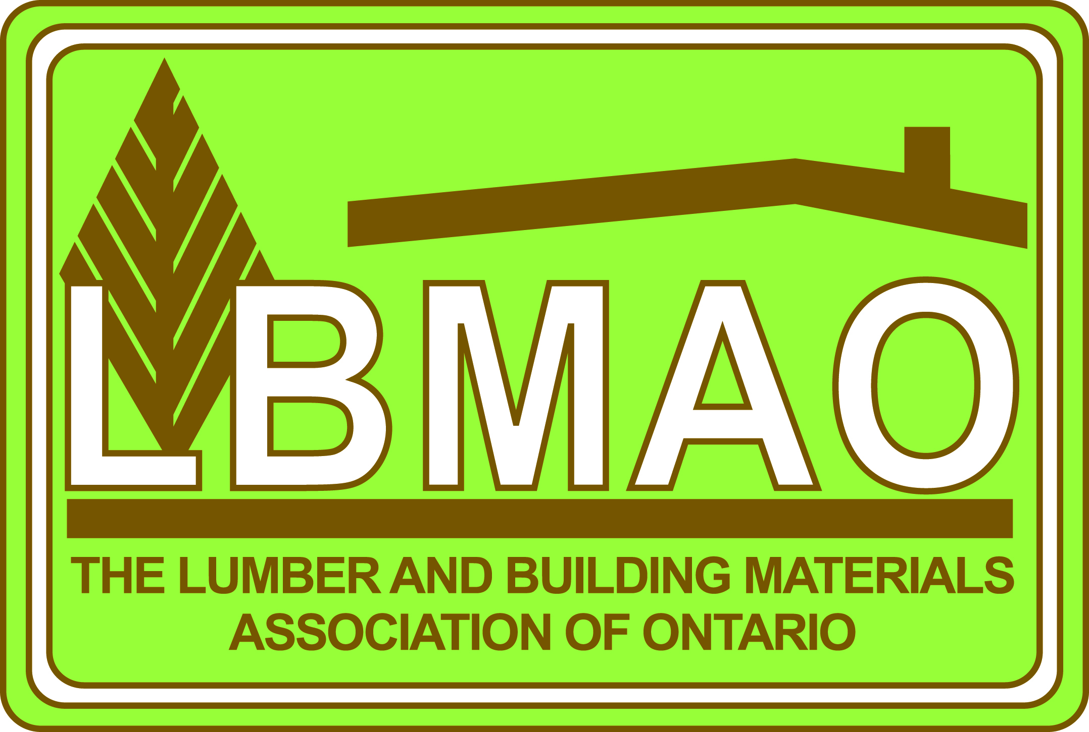

March 14, 2014

Working at Heights Provider Standard Review
Ministry of Labour
10 Dundas Street East, 8th Floor
Toronto, ON M7A 0B2

To Whom It May Concern,

I am writing to respond to your request for comments on the draft proposal for “Working at Heights, Training Program Standard”.

The Lumber and Building Materials Association of Ontario (LBMAO) is a not-for-profit trade association, established in 1917 as an association to represent and provide services for the retail building supply industry and their key suppliers in Ontario. Our members are the independently owned building supply retailers who are also members of buying entities such as Home Hardware, RONA, Castle Building Centres, Timbr-Marts and other independent retailers in Ontario. Our membership represents about 300 retail businesses as well as 220 distributors, manufacturers and agencies who supply product to these retail outlets. Our members are key employers in the communities they live in and service throughout Ontario.

As part of the mandate of the LBMAO, we provide a comprehensive support program in health and safety training and health and safety awareness to our members and we recognize that safety in the workplace has to be a priority for the businesses we work with. Our goal is to ensure that they are aware of and comply with all Ministry of Labour mandatory training programs of which “Fall Protection” is one. Our course is in an online e-learning module that meets current training requirements.

Having reviewed the draft copy of “Working at Heights Training Standard” I would suggest that it is comprehensive and would certainly meet the needs of the construction industry. Working at heights in construction is common and the safety element is critical to ensure minimal exposure to the potential of accidents. However, the draft proposal as it sits now far exceeds the requirements for working at heights for a retail building supply retailer and for many retail environments.

Retail stores that are required to take this training generally have employees who work over 3 metres in height in warehouses that have mezzanines and/or working on extension ladders and portable ladders in retail showrooms and warehouses. Our current training curriculum meets their needs in the proper methods of fall arrest and fall prevention. The delivery method we use is efficient and cost effective and gauges learning outcomes through a testing module.

The “Working at Heights Training Program Standard” as proposed in your draft copy far exceeds the requirements of our retail members and would add a significant challenge to the owners of these retail
businesses in time allocation and costs. In construction we would certainly agree the risk factor is higher than in most retail building supply businesses.

Our suggestion would be to differentiate between construction and retail businesses. Our e-learning module would meet the requirements for the retail trade as required by most of our retail members and wouldn’t require a face-to-face training module which would add significant cost in both time and money for our members and in our opinion is not necessary.

We certainly encourage your endeavors to update and deliver the training standards for fall safety however all businesses don’t have the same level of exposure to hazardous situations and we don’t believe that one standard fits all can apply in this situation. Again, we suggest that a two tiered approach dependent on the level of risk would be more appropriate. Our members are well aware of their responsibilities to providing a safe workplace for their employees and will comply and provide the training expected of them. We simply wish to point out that your proposal exceeds the needs of most of our retail businesses and should be amended to recognize that there are different levels of risk in fall safety management and restraint.

I appreciate the opportunity to put forward our concerns and suggestions.

Kindest Regards,
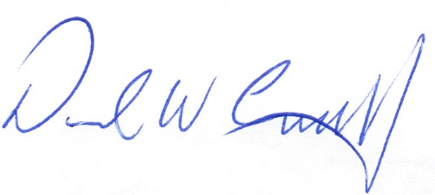
David W. Campbell, President
The Lumber and Building Materials Association of Ontario

